# C:\Users\rubel\Desktop\logo-e1460129908710.jpg

City University

Assingment-2

Department Name: Computer Science & Engineering

Course Code :CSE-325

Course Name:System Analysis & Design

Task Name: Activity Diagram for Atm &

Sequence Diagram for Atm

**Submitted BY**

**Name:Sharmin**

**#ID:** 171442621

**Program:** CSE(Eve)

**Batch:** 44th

**Submitted To**

Supta Richard Philip

Sr.Lecturer, Department

City University,

Date Of Submission:27.06.19

Contents

1.Description…………………………………………………………….…3

2.Task Name: Activity Diagram for Atm………………………….………4

3.What is a sequence diagram in UML?......................................................5

4. Benefits of sequence diagrams………………………………….…..….5

5. Task Name:Sequence Diagram for Atm…………………….……..…..6

**Description:**

This is a UML Activity Diagram example for ATM. Swimlanes are used to represent the participants that take part. The whole process begins at the black start circle at the top and ends at the concentric white/black stop circles at the bottom. The activities are modeled as rounded rectangles.

Draw your activity diagram by using this one as a starting point. Simply Click Use this Template to edit, or click Create Blank to draw from scratch.

**Task Name:Sequence Diagram for Atm**

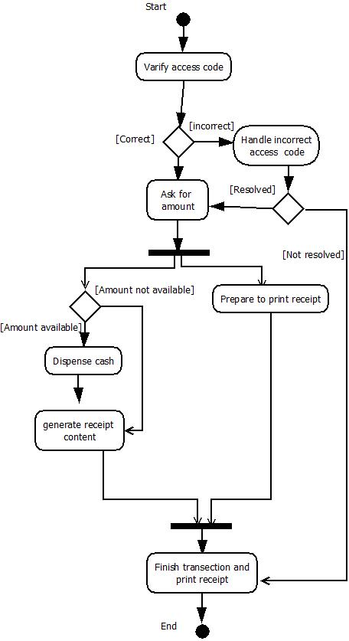

# **What is a sequence diagram in UML?**

To understand what a sequence diagram is, it's important to know the role of the [Unified Modeling Language](https://www.lucidchart.com/pages/what-is-UML-unified-modeling-language), better known as UML. UML is a modeling toolkit that guides the creation and notation of many types of diagrams, including behavior diagrams, interaction diagrams, and structure diagrams.

A sequence diagram is a type of interaction diagram because it describes how—and in what order—a group of objects works together. These diagrams are used by software developers and business professionals to understand requirements for a new system or to document an existing process. Sequence diagrams are sometimes known as event diagrams or event scenarios.  
  
Note that there are two types of sequence diagrams: UML diagrams and code-based diagrams. The latter is sourced from programming code and will not be covered in this guide. Lucidchart’s [UML diagramming software](https://www.lucidchart.com/pages/examples/uml_diagram_tool) is equipped with all the shapes and features you will need to model both.

## **Benefits of sequence diagrams**

Sequence diagrams can be useful references for businesses and other organizations. Try drawing a sequence diagram to:

Represent the details of a UML use case.

Model the logic of a sophisticated procedure, function, or operation.

See how objects and components interact with each other to complete a process.

Plan and understand the detailed functionality of an existing or future scenario.

**Task Name:Sequence Diagram for Atm**

